

**THE SUPERIOR UNIVERSITY**

**Submitted To:**

Mam Iqra

**Name:**

Waqar Abbas

**Roll No:**

SU92-BSDSM-F23-010

**Section:**

BSDS-4A

**OS Lab Task-4**

# **Q: Basic Commands for Linux:**

# **rm -r (Remove Directories and Their Contents)**

Removes a directory and all its contents (files and subdirectories).

Use with caution, as deleted files cannot be recovered.

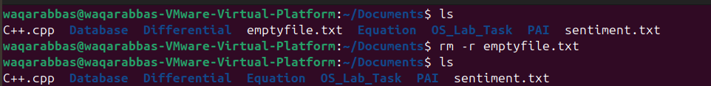

## **rm -ri:**

Recursively deletes a directory but asks for confirmation before deleting each file.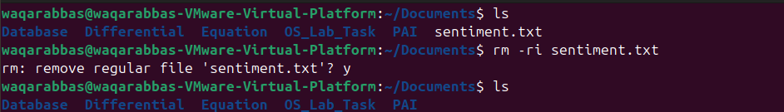

1. **cat > file.txt:**

Creates file or overwrites if it already exists and allows to add content to the file.



## **cat fileName:**

Displays the contents of specified file in the terminal**.**



1. **cat >> fileName:**

Opens specified file and lets you **add more text** to it without overwriting.

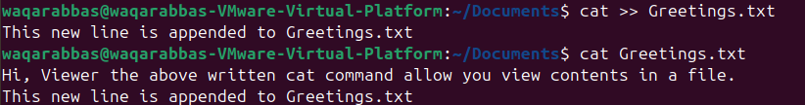

## **cat source_file > destination_file:**

Copies **all content** from source_file to destination_file.